FitFlex

(fitness companion)

**1.Introduction**

* **Project Title:** Fitflex
* **Team ID:**NM2025TMID42605
* **Team size:** 4
* **Team Leader:** Nazini S
* **Email**: [nazinisabi006@gmail.com](mailto:nazinisabi006@gmail.com)

* **Team Members:**

**Name:** Aayla Thabassum F

**Ema**il: [aaylakhan891@gmail.com](mailto:aaylakhan891@gmail.com)

**Name:** Alfiya S

**Email:** [alfiyazoya7@gmail.com](mailto:alfiyazoya7@gmail.com)

**Name:**Shafrin J

**Email:**Shafrinshafrin0207@gmail.com

# Project Overview

# 

FitFlex – Your Personalized Fitness Companion

**Project Summary:**

FitFlex is a mobile fitness and wellness app designed to provide users with customized workout plans, nutrition tracking, and lifestyle coaching. The app combines AI-driven personalization with a flexible, user-friendly interface, making fitness accessible to people of all levels, whether they're working out at home, at the gym, or on the go.

**Goals & Objectives:**

Provide personalized fitness plans based on user goals, preferences, and fitness levels.

Integrate nutrition guidance including meal tracking and diet recommendations.

Offer flexibility in workout location, time, and intensity—"fitness on your terms."

Include wellness features like habit tracking, mindfulness exercises, and sleep tracking.

Enable social and motivational tools such as challenges, progress sharing, and community support.

Ensure cross-platform accessibility (iOS, Android, smartwatch compatibility).

**Target Audience:**

Young adults (18–35) looking for flexible and affordable fitness solutions.

Busy professionals seeking personalized and time-efficient workouts.

Home workout enthusiasts.

Fitness beginners intimidated by traditional gym culture.

**Core Features:**

Personalized Workout Plans:

AI-generated routines based on fitness goals (e.g., fat loss, muscle gain, endurance).

Home and gym workouts with instructional videos.

Adaptive intensity and progress tracking.

Nutrition Tracking & Meal Plans:

Calorie and macro tracking.

Meal plan suggestions based on dietary preferences (e.g., vegan, keto, gluten-free).

Barcode scanner and food database.

Progress Tracking:

Visual dashboards for weight, reps, workout history.

Sync with wearables (Fitbit, Apple Watch, Google Fit).

Wellness & Lifestyle Tools:

Habit builder and reminders.

Guided meditations and breathing exercises.

Sleep tracking.

Community & Motivation:

Fitness challenges and leaderboards.

Social sharing of achievements.

Integration with friends or fitness groups.

Technology Stack (Sample):

Frontend: React Native / Flutter

Backend: Node.js with Express / Firebase

Database: MongoDB / Firestore

AI/ML: TensorFlow Lite / OpenAI for coaching and recommendations

APIs: HealthKit, Google Fit, Nutritionix API

**Monetization Strategy:**

**Freemium model** – free basic features, premium for advanced features

Subscription tiers – monthly/yearly plans

In-app purchases (e.g., exclusive programs, coaching)

Partner promotions (e.g., fitness brands, health food)

**Success Metrics:**

User retention & engagement rates

Daily/Monthly active users (DAU/MAU)

Conversion to premium

User satisfaction (ratings, reviews)

Community growth and challenge participation

Would you like this formatted as a slide deck, PDF, or expanded into a full business plan or pitch deck? Also, let me know if this is a startup pitch, a school project, or for internal use—that way I can refine the tone and content.

Top of Form

Attach

Search

Study

Voice

# Bottom of Form

# Architecture

# Frontend (Client-side)

Built using React Native (mobile) or React.js/Next.js (web).  
Key features:

User authentication (login/signup)

Workout plans and video player

Nutrition tracking and food diary

Progress tracking (charts, goals)

Community/forum section

Notifications and settings

# **Technologies:**

React Native / Flutter

Axios (API calls), Redux/Zustand (state)

Firebase/OneSignal (push notifications)

Secure storage for tokens

# **Backend (Server-side)**

Built using Node.js (Express/NestJS) or Python (FastAPI).  
**Key services:**

Auth (JWT, OAuth)

Workout & Nutrition services

User profiles & progress tracking

Community & chat features

Payment/subscription with Stripe

Notifications (email/push)

# **Technologies:**

PostgreSQL + Redis

AWS S3 (media storage)

WebSockets for real-time chat

Docker + CI/CD for deployment

# Setup Instructions

# 

* **Prerequisites:**
  + Node.js
  + MongoDB
  + Git
  + React.js
  + Express.js **–** Mongoose **–** Visual Studio Code

# Installation Steps:

# 

# Clone the repository git clone

# Install client dependencies cd client npm install

# Install server dependencies cd

../server npm install

# Folder Structure

# 

SB-Works/

|-- client/ # React frontend

|__components/ L__ pages/

|__ server/ # Node.js backend

|__routes/

|__ models/

|__ controllers/

# Running the Application

* **Frontend:**

cd client npm

start • **Backend:**

cd server npm start

* **Access:** Visit http://localhost:3000

# API Documentation

* **User:**
  + /api/user/register
  + /api/user/login
* **Projects:**
  + /api/projects/create
  + /api/projects/:id • **Applications:** /api/apply
* **Chats:**
  + /api/chat/send **–** /api/chat/:userId

# Authentication

* JWT-based authentication for secure login
* Middleware protects private routes

# User Interface

* Landing Page
* Freelancer Dashboard
* Admin Panel
* Project Details Page

# Testing

* Manual testing during milestones
* Tools: Postman, Chrome Dev Tools

# 11.Screenshots or Demo

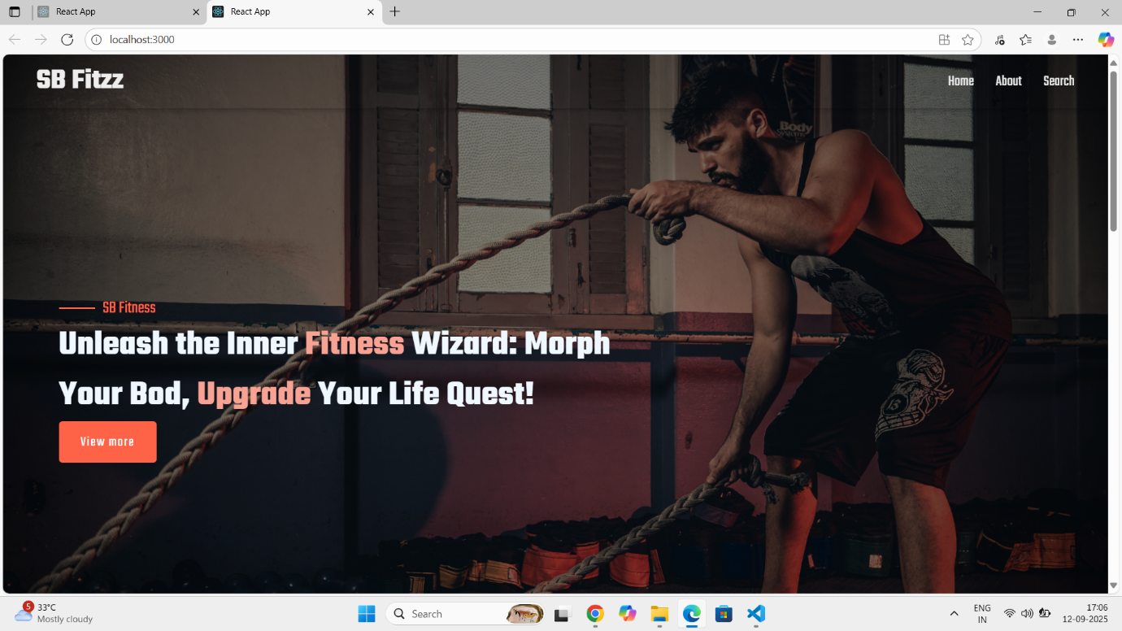

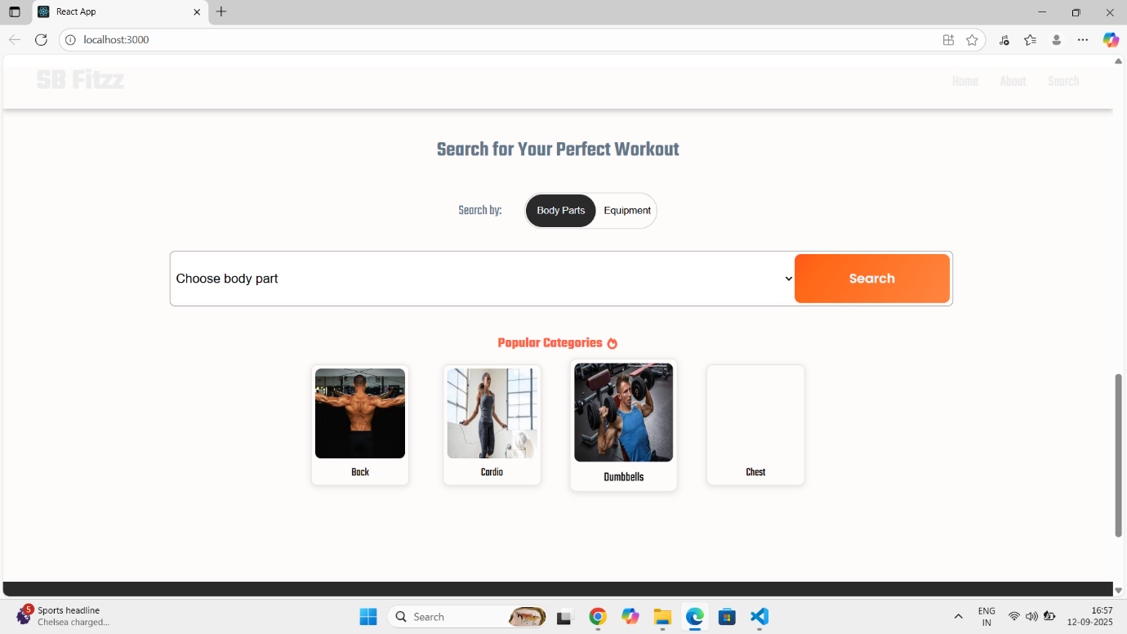

# 12.Future Enhancements

**1. AI-Powered Personalized Workouts**

* Use AI to analyze user performance, preferences, and goals to generate **customized workout plans**.
* Adapt routines weekly based on progress or feedback (e.g., "Too hard," "Too easy," "Loved it").

**2. Wearable Integration**

* Sync with smartwatches (Apple Watch, Fitbit, Garmin) for **real-time data tracking**:
  + Heart rate
  + Calories burned
  + Sleep quality
  + Activity level

**3. Nutrition & Meal Planning**

* Add a **meal planning** feature with:
  + AI-generated meal plans
  + Barcode scanner for logging food
  + Calorie and macronutrient tracking
* Optional: Partner with a nutritionist to offer certified advice.

**4. Community Features**

* Social interaction via:
  + Group challenges
  + Workout leaderboards
  + Community forums or support groups (e.g., "Weight Loss Journey," "Postpartum Fitness")

**5. Gamification**

* Introduce a reward system:
  + Earn points for completing workouts
  + Unlock badges or streaks
  + Redeem points for partner discounts (e.g., fitness gear or supplements)

**6. Progress Visualization Dashboard**

* Advanced graphs showing:
  + Weight and body measurements
  + Workout consistency
  + Mood tracking correlation with exercise
  + Before/after photo timeline (private or shareable)

**7. Virtual Coaching & Live Classes**

* Book live sessions with certified trainers.
* Stream live or pre-recorded classes for different fitness levels (HIIT, yoga, strength training, etc.).

**8. Voice & Gesture Controls**

* Hands-free mode using voice commands (ideal during workouts).
* Motion detection using device camera for form correction or counting reps.

**9. Mental Wellness Integration**

* Guided meditation and breathing exercises.
* Mental wellness tips synced with workout intensity (e.g., rest days with mindfulness focus).

**10. AI Chat Assistant (In-App Coach)**

* Chatbot to:
  + Answer fitness-related questions
  + Recommend workout modifications
  + Provide motivation and reminders